Research project for Master student or Research assistant – Université de Neuchâtel

Acoustic and information transmission of chimpanzee pant hoots

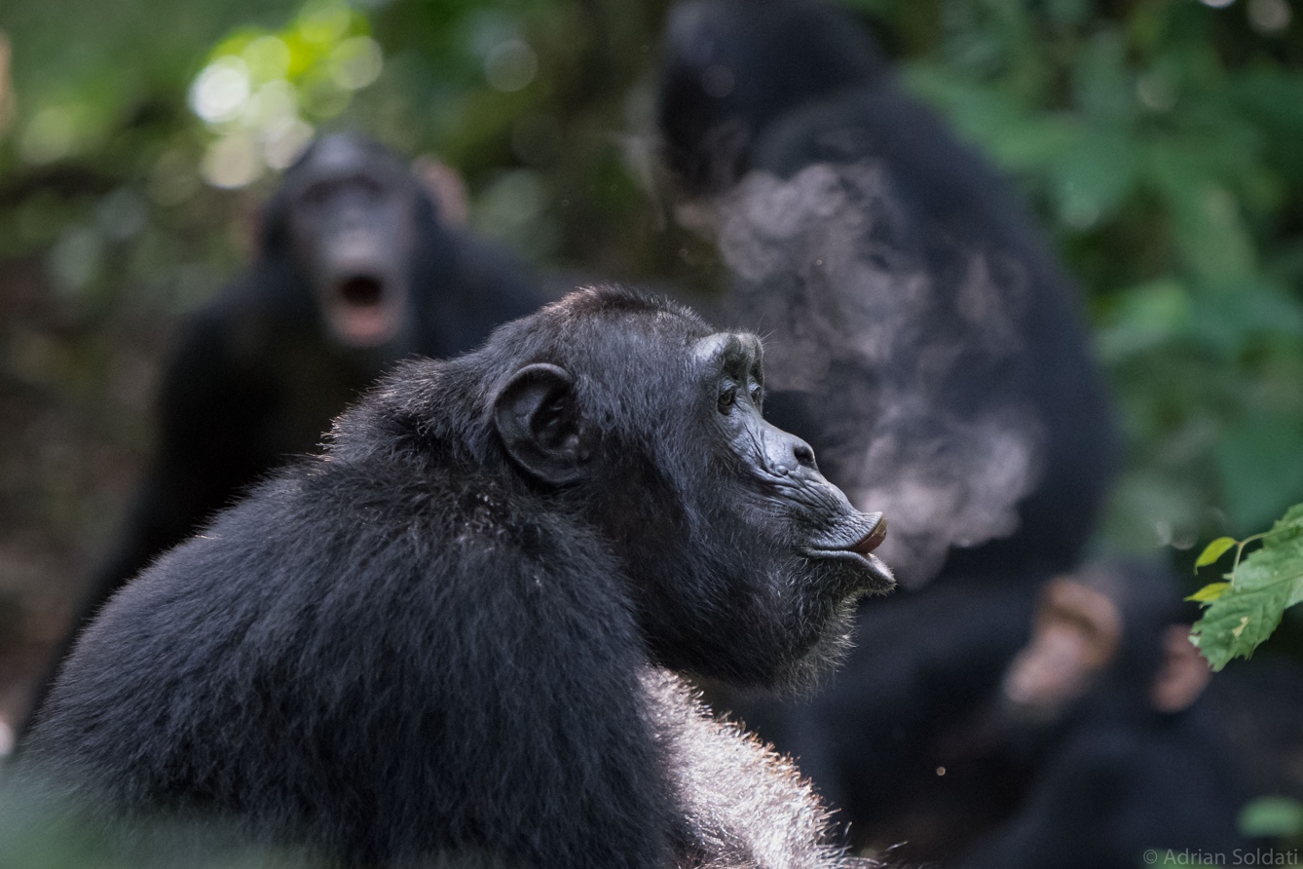

The pant hoot is among the most characteristic calls of chimpanzees and is used every day by field researchers to locate individuals in the forest since it travels long distances (Mitani & Nishida 1993). This vocalization presents inter-individual differences (Mitani et al. 1996), inter-community differences (Crockford et al. 2004), and its acoustic structure contains information about the identity of the provider (Fedurek et al. 2016). As a result, experienced researchers and field assistants can learn to recognize which types of pant hoots they hear in the forest, estimate the distance, and tell the sex and the identity of the provider. However, even though usually presumed to be true, this competence has not been validated yet, leaving a gap in the chimpanzee literature as well as an interesting feature of inter-species recognition of communicative signals and the information they transmit to be studied (see on Orang-utans, Lameira & Wich 2008). Chimpanzees pant hoots have mainly been investigated from the producer perspective. However, we know individuals engage in vocal exchanges, with back and forth between physically separate parties, and respond either vocally or behaviourally after hearing certain individuals, types of calls or showing no apparent change of state. Hearing a call in a highly social species like chimpanzees is important for the decision-making they engage on a daily basis regarding feeding, traveling, mating, and social bonding. In order to advance our understanding of the social function of this vocalization it is important to consider the receiver’s perspective and validate a method which will serve as the base for further investigations.
The main goal of this project is to study the propagation and degradation pant hoot vocalizations through the forest at the Budongo Conservation Field Station (Uganda) and to test the ability of researchers and field assistant to hear, categorize, and identify its features transmitted at various distances. It involves two parts of fieldwork: working directly with wild chimpanzees, for the collection of vocalizations, and indirectly, through playback experiments on humans, in order to test our ability of recognition and methods of data collection regarding chimpanzees vocal communication.

Methods
- Measuring and recording pant hoot vocalization distance of travel across the forest.
- Assessing which phases (intro, build-up, climax, let-down, and drumming) can be heard at which distances and how they degrade over distance.
- Testing researchers and Field Assistants with a playback experiment on their abilities to recognize features of the call and estimate distance of transmission.
- Opportunistic collection of pant hoot recordings.

This project is supervised by Prof Klaus Zuberbühler and Adrian Soldati. If you are interested in the project or have any questions please send an email to adrian.soldati@unine.ch

References
Crockford, C. et al., 2004. Wild Chimpanzees Produce Group-Specific Calls: a Case for Vocal Learning? Ethology, 110, pp.221–243.
Fedurek, P., Zuberbühler, K. & Dahl, C.D., 2016. Sequential information in a great ape utterance. Scientific Reports, 6(1), pp.1–11.
Lameira, A.R. & Wich, S.A., 2008. Orangutan Long Call Degradation and Individuality Over Distance: A Playback Approach. International Journal of Primatology, 29, pp.615–625.
Mitani, J.C. & Nishida, T., 1993. Contexts and social correlates of long-distance calling by male chimpanzees. Animal Behaviour, 45(4), pp.735–746.
Mitani, J.C., Gros-Louis, J. & Macedonia, J.M., 1996. Selection for Acoustic Individuality Within the Vocal Repertoire of Wild Chimpanzees. International Journal of Primatology, 17(4), pp.569–583.

